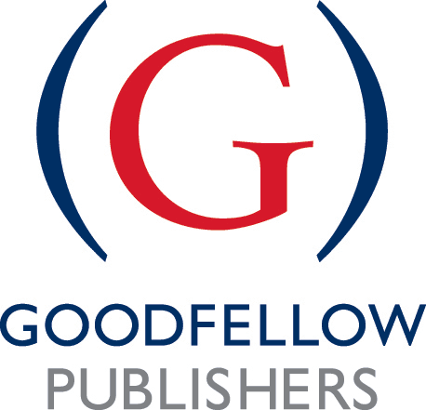

Goodfellow Survey: The Next Big Thing!

This is a survey of authors and experts we are conducting here at Goodfellow Publishers to investigate what the new and upcoming topics are in your area of teaching and research.

Our aim is to clarify and provide insights into key new areas and offer analysis and conclusions that will be useful to all involved in the fields of tourism, hospitality and events. It will also help us find out what topics we should be looking to publish in the short-term future so that we can continue to serve the needs of our readers and authors and keep them and us abreast of all the hottest topics.

We would therefore really appreciate it if you could spare the time to answer the short questions below please. All responses will be kept anonymous.

We will be publishing the combined, anonymised results of the survey via our Facebook page. I’m also happy to email you directly with the results (if you would like that do let me know).

Please add your answers below each question below. Ideally 100 words or so each, but short comments or bullet points are welcome too.

1.What books have not yet been written on tourism, hospitality and events that you think should be written?

………………………………………………………………………………………………………………………………………………………………………………………………………..

…………………………………………………………………………………………………………………………………………………..…………………………………………………..

…………………………………………………………………………………………………………………………………………………..…………………………………………………..

2. What are the key future topics in your area?

…………………………………………………………………………………………………………………………………………………..…………………………………………………..

…………………………………………………………………………………………………………………………………………………..…………………………………………………..

…………………………………………………………………………………………………………………………………………………..…………………………………………………..

3.What style/format/media should this information be published in?

…………………………………………………………………………………………………………………………………………………..…………………………………………………..

…………………………………………………………………………………………………………………………………………………..…………………………………………………..

…………………………………………………………………………………………………………………………………………………..…………………………………………………..

4.What are your current interests – what subjects are you writing about now?

…………………………………………………………………………………………………………………………………………………..…………………………………………………..

…………………………………………………………………………………………………………………………………………………..…………………………………………………..

…………………………………………………………………………………………………………………………………………………..…………………………………………………..
Thank you in advance for your time and input here - it is very much appreciated. We look forward to reading your responses.

With thanks and all best wishes, Sally (North), Editorial Director.
Please email your responses to me at sally.north@goodfellowpublishers.com

